**Ex. 10. Form validation using ANGULARJS**

**URK17CS127**

**Date:**

To design a single page web application using HTML5 and validate the user inputs using AngularJS.

**Part 1: HTML inputs**

**1. Required**

AngularJS provides a **ng-required** directive have the flexibility to set the input field should have a value or not. The following syntax is used to make sure that the input field should not be empty. We can set it to false if you do not want to restrict this.

<input type="text" ng-required="true" />

**2. Minimum Length**

The directive **ng-minlength** is used to validate the minimum length of the input value. This will make sure that the length of the entered value not less than the value set using ng-minlength directive.

<input type="text" ng-minlength=10>

**3. Maximum Length**

The directive **ng-maxlength** is used to validate the maximum length of the input value. This will make sure that the length of the entered value is not more than the value set using ng-max length directive.

<input type="text" ng-maxlength=20 />

**4. Pattern**

The **ng-pattern** directive is used to ensure that an input matches a regex pattern, the following syntax is used.

<input type="text" ng-pattern="[a-zA-Z]">

**5. Email**

We can set the input type to email to ensure that the input field is a valid email id.

<input type="email" name="email" ng-model="user.email">

**6. Number**

We can set the input type to number to ensure that the input field is a number.

<input type="number" name="age" ng-model="user.age">

**7. URL**

We can set the input type to url to ensure that the input field is a url.

<input type="url" name="homepage" ng-model="user.url">

**Part 2: Angular Form Validation Properties**

Angular provides properties on forms to keep track of all its controls and nested forms as well as the state of them, such as being valid/invalid or dirty/pristine. The following table describes those properties and corresponding angular classes that help us to validate forms.

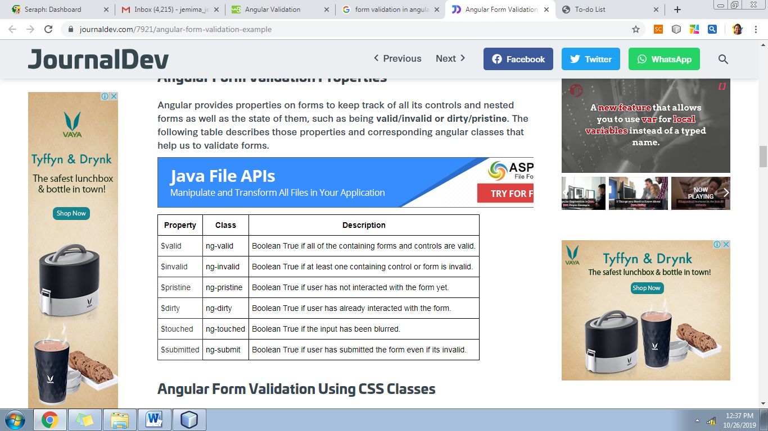

**Part 3: Angular Form Validation Using CSS Classes**

While handling forms angularJS adds specific classes to the form based upon their state. To allow styling of form as well as controls, ngModel adds these CSS classes:

* ng-valid
* ng-invalid
* ng-pristine
* ng-dirty
* ng-touched
* ng-untouched

**Sample Code**

<!doctype html>

<html>

<head>

<meta charset="UTF-8">

<title>AngularJS Form Validation</title>

<script type="text/javascript" src="angular.min.js"></script>

<style type="text/css">

.f1 input.ng-invalid.ng-touched

{

background-color:red;

}

.f1 input.ng-valid.ng-touched

{

background-color:green;

}

</style>

</head>

<body ng-app="formApp" ng-controller="fctrl">

<form name="form" novalidate class="f1">

Name : <input type="text" ng-model="employee.name" required><br>

E-mail : <input type="email" ng-model="employee.email" required><br>

Role : <input type="radio" ng-model="employee.role" value="development">Development

<input type="radio" ng-model="employee.role" value="testing">Testing<br><br>

<input type="button" ng-click="reset()" value="Reset">

<input type="submit" ng-disabled="form.$invalid" ng-click="save(employee)" value="Submit" />

</form>

<p>Employee Form = {{employee}}</p>

<p>Master = {{master}}</p>

<script>

var app = angular.module('formApp',[]);

app.controller('fctrl', function($scope){

$scope.master = {};

$scope.save= function(employee) {

$scope.master = angular.copy(employee);

}

$scope.reset = function() {

$scope.employee = angular.copy($scope.master);

}

});

</script>

</body>

</html>

**Sample Valid Page Output**

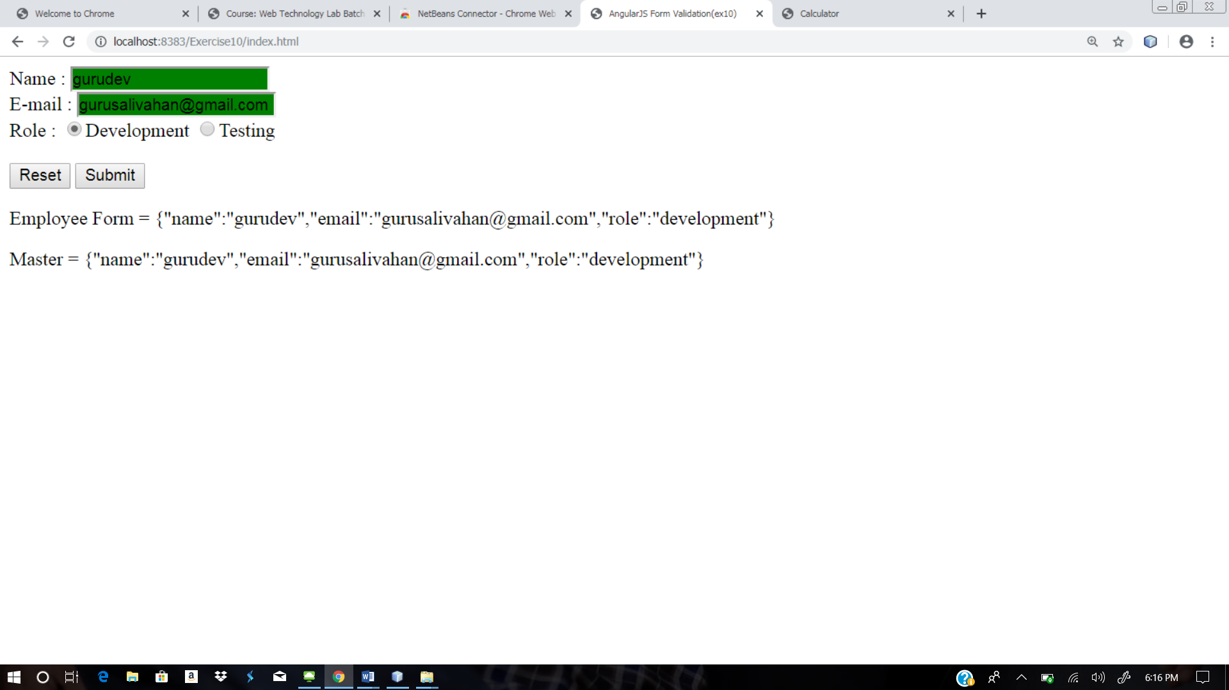

**Sample Invalid Page Output**

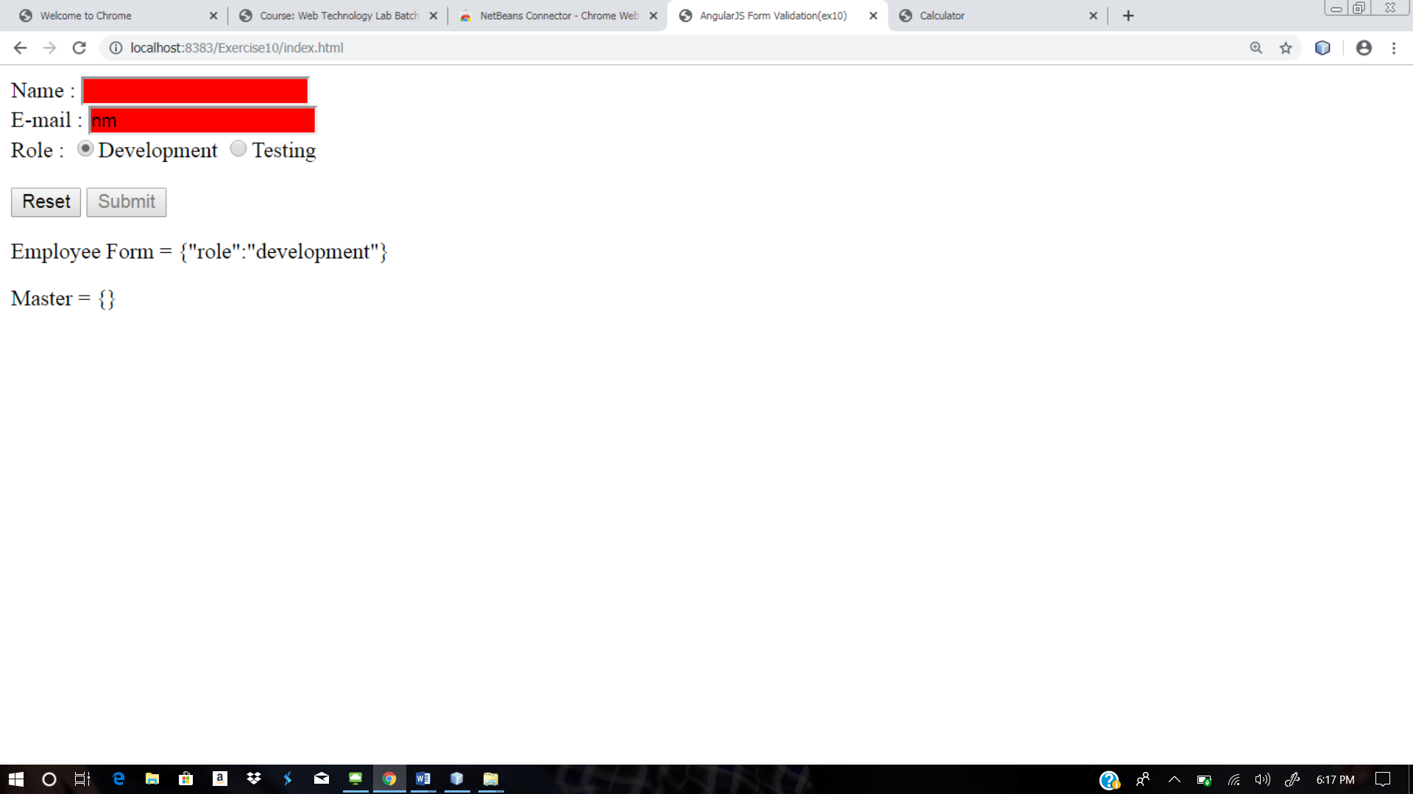

**Web site URL:** <http://urk17cs127.rf.gd/Exercise10/>

**You tube URL:** [**https://youtu.be/QAT-NvxhD7w**](https://youtu.be/QAT-NvxhD7w)